Basic Lewis Dot Structure Comparison of C2H6O

GroveDraw

Structural Configuration Information

In the design of the structure drawing software, atoms and bonds are assigned unique ID numbers. Atoms also have a type (such as Carbon, Oxygen, Hydrogen). This is based on a simple incremental system. An atom assigned the id atom_ID can be represented as:

Atom (atom_ID)

An ID is assigned to an atom, atom_ID, and the next atom placed on the canvas will be assigned the ID of atom_ID+1. This second atom can be represented as:

Atom (atom_ID+1)

If the first atom (atom_ID) is deleted, the next atom placed will still be assigned an ID of atom_ID + 2.

The same incremental ID system is used for bonds. A bond also maintains an array containing the IDs of the atom that it connects.

A bond assigned as bond_ID that connects Atom (atom_ID) and Atom (atom_ID+1) can be represented as:

Bond (bond_ID, [atom_ID, atom_ID+1])

The incremental ID system means that in any structure, even “identical” ones, there may always be a difference in the IDs of the atoms and bonds placed on the canvas, dependent on if the user a) deleted any atom and placed more or b) placed atoms in a different order.

C2H6O

20 Valence Electrons Total

8 Single Bonds

Oxygen has (2) pairs of Valence Electrons

Figure 1 below shows a correctly drawn structure of C2H6O using the GroveDraw application.

**This structure:**

Correct Number and Types of Atoms (2 Carbons, 6 Hydrogens, 1 Oxygen)

20 Valence Electrons total

8 Single Bonds

Oxygen has (2) pairs of valence electrons

Oxygen (ID: 3) atom is bound to Carbon (ID: 2) and Hydrogen (ID: 9) atom.

Carbon (ID: 1) is bound to three Hydrogen (IDs: 4,5,6)

Carbon (ID: 2) is bound to two Hydrogen (IDs: 7, 8) and one Oxygen (ID: 3).

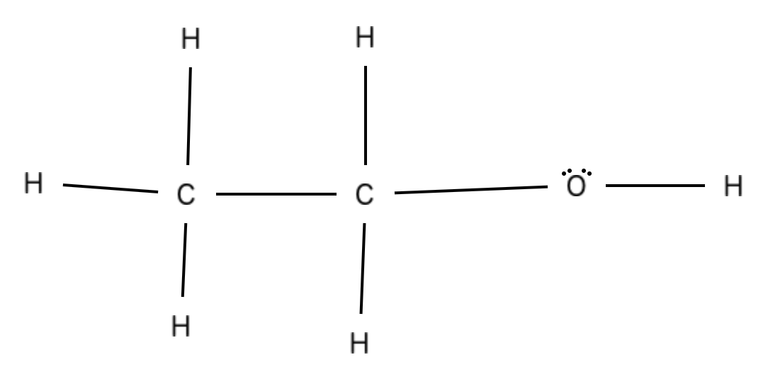

Fig. 1. Correctly drawn structure of C2H6O

Figure 2 below shows a correctly drawn structure of C2H6O using the GroveDraw application.

**This structure:**

Correct Number and Types of Atoms (2 Carbons, 6 Hydrogens, 1 Oxygen)

20 Valence Electrons total

8 Single Bonds

Oxygen has (2) lone pairs of valence electrons

Oxygen (ID: 3) atom is bound to two Carbons (ID: 1, 2).

Carbon (ID: 1) is bound to three Hydrogen (IDs: 4,5,6) and one Oxygen (ID: 3).

Carbon (ID: 2) is bound to three Hydrogen (IDs: 7, 8, 9).

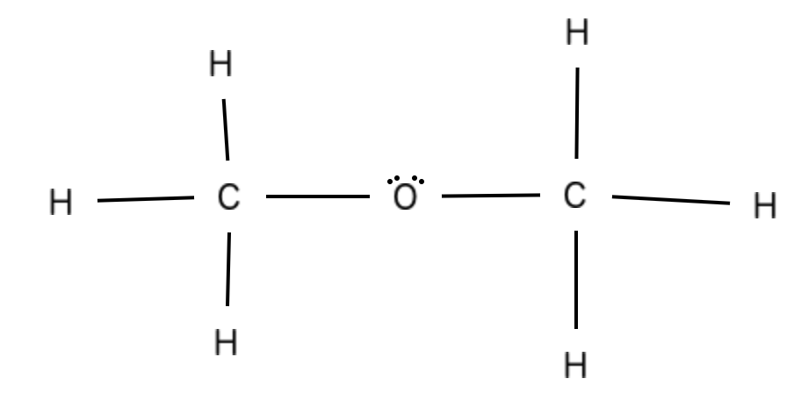

Fig. 2. Correctly drawn structure of C2H6O

Figure 3 below shows an incorrectly drawn structure of C2H6O using the GroveDraw application.

**This structure:**

Incorrect Number and Types of Atoms (2 Carbons, 5 Hydrogens, 1 Oxygen)

18 Valence Electrons total

7 Single Bonds

Carbon (ID: 2) has an incomplete valence shell

Hydrogen (ID: 8) has an expanded valence shell

Oxygen has (2) lone pairs of valence electrons

Oxygen (ID: 3) atom is bound to one Hydrogen (ID: 8).

Carbon (ID: 1) is bound to three Hydrogen (IDs: 4,5,6) and one Carbon (ID: 2).

Carbon (ID: 2) is bound to two Hydrogens (IDs: 7, 8).

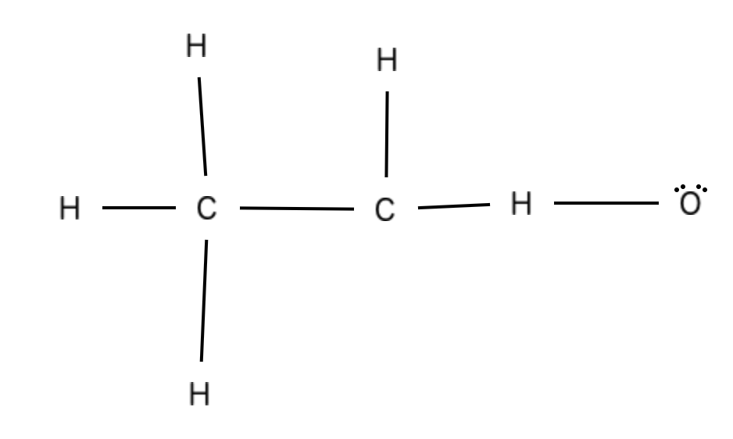

Fig. 3. Incorrectly drawn structure of C2H6O

Figure 4 below shows an incorrectly drawn structure of C2H6O using the GroveDraw application.

**This structure:**

Incorrect Number and Types of Atoms (2 Carbons, 5 Hydrogens, 1 Oxygen)

20 Valence Electrons total

7 Single Bonds

Carbon (ID: 2) has an incomplete valence shell

Hydrogen (ID: 8) has an expanded valence shell

Oxygen has (3) lone pairs of valence electrons

Oxygen (ID: 3) atom is bound to one Hydrogen (ID: 8).

Carbon (ID: 1) is bound to three Hydrogen (IDs: 4,5,6) and one Carbon (ID: 2).

Carbon (ID: 2) is bound to two Hydrogens (IDs: 7, 8).

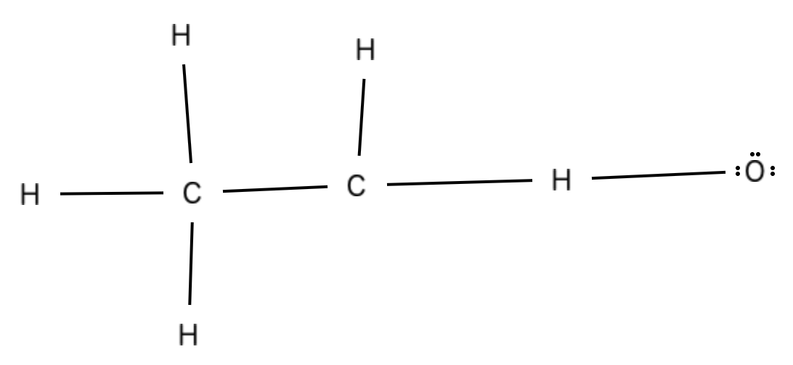

Fig. 4. Incorrectly drawn structure of C2H6O

Figure 5 below shows an incorrectly drawn structure of C2H6O using the GroveDraw application.

**This structure:**

Correct Number and Types of Atoms (2 Carbons, 6 Hydrogens, 1 Oxygen)

20 Valence Electrons total

7 Single Bonds

1 Double Bond

Carbon (ID: 2) has an expanded valence shell

Oxygen has (1) lone pairs of valence electrons

Oxygen (ID: 3) atom is bound to one Hydrogen (ID: 8).

Carbon (ID: 1) is bound to three Hydrogen (IDs: 4,5,6) and one Carbon (ID: 2).

Carbon (ID: 2) is bound to two Hydrogens (IDs: 7, 8).

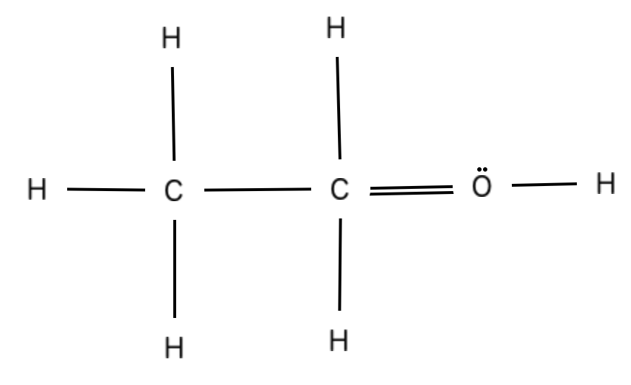

Fig. 5. Incorrectly drawn structure of C2H6O

**Priority Tests for Structure Correctness**

**These tests that can quickly determine the correctness of a structure.**

1. **Total Number of Atoms and Atom Types –** this is an easy check to do to immediately see if a structure is incorrect. An correct structure will always have the correct number and types of atoms.
2. **Total Number of Valence Electrons –** this is an easy check to do to immediately see if a structure may be correct. It is possible for a structure to be **incorrect** and have the **correct** **expected** number of electrons.

**Conditional Tests**

**If Hydrogens are present:**

**Expanded Valence Shells on Hydrogens –** this is another easy check to do to immediately check if a structure is incorrect. Hydrogen will never have more than **one (1)** bond.

**If carbon is present:**

**If Oxygen is present:**

**If Nitrogen is present:**

**Possible Tests (unclassified)**

1. **Total Number of Bonds and Bond Types –** The total number of bonds and what types of bonds they are may be helpful in determining structure correctness

Feedback needs to get more specific

Feedback can be in a form of a question